Rechargeable Batteries
Type | Uses and Description | Disposal
Nickel Cadmium (Ni-Cd) | - These batteries are typically used in cordless power tools, cordless phones, digital and video cameras, two-way radios, bio-medical equipment and video cameras.  - They may look like single-use AA, AAA or other alkaline batteries or a battery pack shaped for specific tools. | Removable batteries: Removable rechargeable batteries can be brought to specialized battery recyclers, participating retailers that provide battery takeback services, or local household hazardous waste collection programs. Contact the manufacturer or your local household waste authority for other management options.  Non-removable batteries contained in electronic devices: Entire devices can be brought to certified electronics recyclers, participating retailers that provide electronics takeback services, or local electronics or household hazardous waste collection programs.  Handling precautions: Place each battery in a separate plastic bag or place non-conductive tape (e.g., electrical tape) over the battery’s terminals. Handle any damaged battery with care and appropriate personal protective equipment. If a lithium-ion battery becomes damaged, contact the battery or device manufacturer for specific handling information.  EPA recommendation: Look for labels identifying battery chemistry. Do not put rechargeable batteries in the trash or municipal recycling bins. Find a recycling location near you:  - Ni-Cd  - Li-ion  - Ni-MH  - Ni-Zn  - Pb
Lithium-Ion (Li-ion)  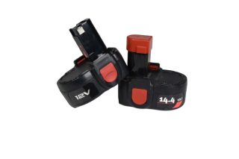  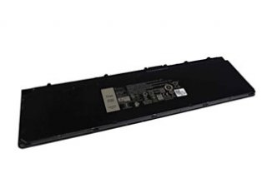 | - Commonly found in older cellphones, power tools, digital cameras, laptops, children’s toys, e-cigarettes, small and large appliances, tablets and e-readers.  - Some Li-ion batteries are not easily removed from the product and can become problematic as a fire hazard if they are broken, bent or crushed.
Nickel Metal Hydride (Ni-MH)  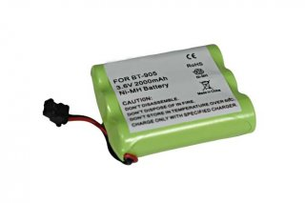 | - Commonly found in cellphones, cordless power tools, digital cameras and two-way radios.  - These batteries are not as common as they once were.
Nickel-Zinc (Ni-Zn) | - Commonly found in digital cameras, wireless keyboards and small electronics.
Small-Sealed Lead Acid (Pb) | - Commonly found in mobility scooters, children’s toy cars, emergency lighting and hospital equipment. Also used for backup power in residential landline phones and uninterruptable power supplies for computers.

