Lithium-Ion Battery Recycling

Find a Recycling Location Near You
To find a battery recycling location near you, consult the following resources:
- Earth911.
- Call2Recycle.
- Consumer Technology Association's Greener Gadgets.
Disclaimer: These sites are listed for informational purposes only. U.S. EPA does not endorse any of these entities or their services.
On this page:
- Background on Lithium Batteries
- Lithium-Ion Batteries as Waste
- How Lithium-Ion Batteries are Recycled
- Lithium-Ion Battery Reuse
- Additional Resources

Background on Lithium Batteries
Lithium-ion batteries are a type of commonly used rechargeable batteries that vary in size and design, but work in very similar ways. A battery is made of one or more cells, with each individual cell functioning to produce electricity.
A cell contains an anode layer, a cathode layer, and a separator, all of which are in contact with an electrolyte, which is most often a liquid. These components are stacked or rolled together and placed in an outer packaging— typically either a steel can or an aluminum/polymer pouch material.
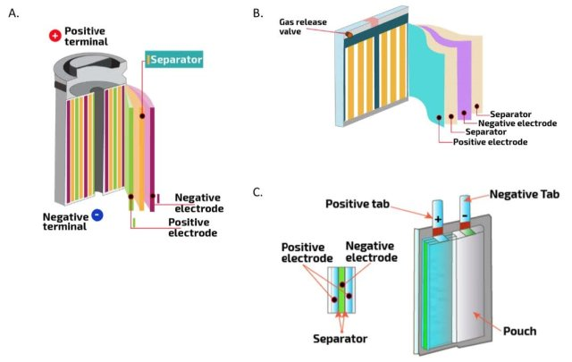
Schematics of various form factors for Li-ion cells, including: A) cylindrical, B) prismatic, and C) pouch. Source: Sandia National Laboratory. Click to enlarge.
The different types of lithium-ion batteries are named for the chemicals used inside their cells, particularly the cathode chemistry. There are many variations of lithium-ion batteries, but some common types include:
- Lithium cobalt oxide.
- Lithium nickel cobalt aluminum oxide.
- Lithium iron phosphate.
Lithium-ion batteries of different chemistries will differ in how much total energy they can provide in one charge, how quickly that energy is released, how stable the battery is, how quickly it can be recharged, and how many total times it can be charged and discharged, among other variables. Because of these differences, certain chemistries are commonly used for specific applications. For example, lithium cobalt oxide chemistries are common in consumer electronics while lithium nickel cobalt aluminum oxide chemistries are often used for electric vehicle batteries.
Although the mix of materials used for different chemistries of lithium-ion batteries varies, common materials used are:
- Lithium.
- Nickel.
- Cobalt.
- Manganese.
- Graphite.
- Iron.
- Copper and aluminum foils.
- Electrolyte that is usually flammable.
According to the United States Geological Survey’s 2022 list, of these commonly used materials, aluminum, lithium, nickel, cobalt, manganese, and graphite are all critical minerals, which means they are very important to national security and the U.S. economy.
Lithium-ion batteries come in various cell, module, and pack sizes, with multiple cells making up a module and multiple modules making a battery pack. Battery packs for applications needing more energy such as an electric vehicle may require hundreds or even thousands of cells packaged together as multiple modules, though there is wide variety in how battery packs are designed in the industry. The term “battery” may be used to describe a cell—a single energy-producing unit—as well as a module or an entire pack.
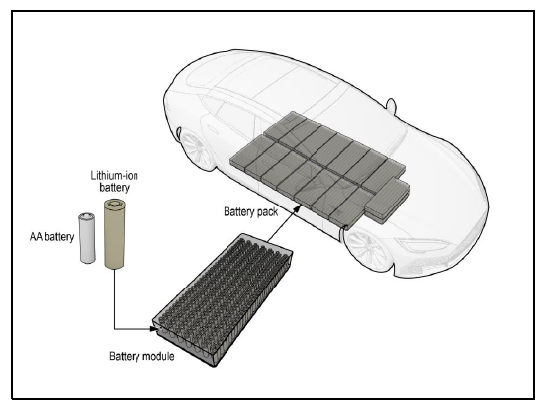
Diagram showing the components of an electric vehicle battery pack, which is made up of numerous modules and many cells. Source: U.S. National Transportation Safety Board. Click to enlarge.

Lithium-Ion Batteries as Waste
Despite all these variations, EPA determined that most lithium-ion batteries on the market are likely to be hazardous wastes when they are disposed of because they may catch fire or explode if not handled carefully. Most lithium-ion batteries when discarded would likely be considered ignitable and reactive hazardous wastes (carrying the waste codes D001 and D003, respectively). Please note that lithium-ion batteries in consumer electronics and electric vehicles are generally safe if purchased from a trustworthy manufacturer and used appropriately. However, fires at end of life are common and mismanagement and damage to batteries make them more likely at that stage.
Recycling used lithium-ion batteries (and the devices that contain them) will help address emerging issues associated with the clean energy transition and prevent problems caused by inappropriate battery disposal. End-of-life lithium-ion batteries contain valuable critical minerals needed in the production of new batteries. Clean energy technologies like renewable energy storage systems and electric vehicle batteries will demand large amounts of these minerals, and recycling used lithium-ion batteries could help meet that demand.
In the near term, batteries from consumer sources, such as cell phones and laptops, will make up an important share of the batteries sent for recycling. Making sure these smaller lithium-ion batteries get collected and recycled will support the growing battery recycling industry in the U.S. Sending end-of-life batteries for recycling also keeps them out of the household garbage and recycling systems, where they can start fires and endanger workers and nearby communities.
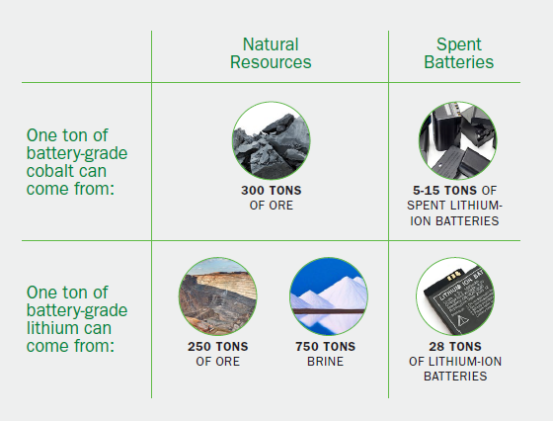
Source: U.S. Department of Energy Vehicle Technologies Office.

How Lithium-Ion Batteries are Recycled

How to Choose a Responsible Recycler
For information on how to choose a responsible recycler, read our fact sheet (pdf).
Another way to choose a responsible recycler is to find recyclers that operate under recycling standards set by accredited organizations like SERI’s R2 Standard or the e-Stewards standard.

Recycling Overview
Safe recycling of lithium-ion batteries at the end of their lives conserves the critical minerals and other valuable materials that are used in batteries and is a more sustainable approach than disposal. Although there is not one path that all batteries take at the end of their lives, lithium-ion battery recycling usually follows a similar series of steps.
In the typical first step, consumer electronics, batteries, and battery-containing devices are collected by the retailer who sold the replacement item, by a storefront e-waste collector, or by a business that specializes in collecting other companies’ used electronics. Electric vehicle batteries may end up at a dealership or automobile mechanic shop, if the vehicle’s battery needed to be replaced, or at an automobile disassembler, if the entire vehicle reached the end of its life. In all cases, batteries then need to be identified and sorted for proper recycling and may change hands several times in the process, getting shipped to other collection facilities before arriving at a facility that can process them. Larger battery packs, such as those from electric vehicles, could be partially disassembled at any time in this process into cells or modules to make transportation, storage, and processing easier.
Some battery packs or modules may also be evaluated for repair or reuse—either being put back into a device similar to their original one or being repurposed in a different type of product or application. For example, some companies are experimenting with repurposing used electric vehicle batteries to store excess electricity generated by solar panels. Battery packs that can be repaired may have one or more "bad" modules replaced before being put back into use in the original or other appropriate applications.
When a battery is sent for recycling after collection and evaluation, a common next management step is shredding. Depending on the size of the shredding equipment, part or all of the battery is shredded. In some cases, a portion of a device containing a battery may also be shredded. The batteries are either discharged to remove electricity before this step or are otherwise managed to prevent fires during shredding. Many battery recyclers are also accepting battery materials in the form of manufacturing scrap for processing.
The shredding operation creates a number of different streams, including the following:
- “Black mass”” (a granular material made up of the shredded cathodes and anodes of the batteries).
- Copper and aluminum foils (which held the anode and cathode material).
- Separators (thin plastic films).
- Other plastics.
- Steel canisters.
- Electrolyte.
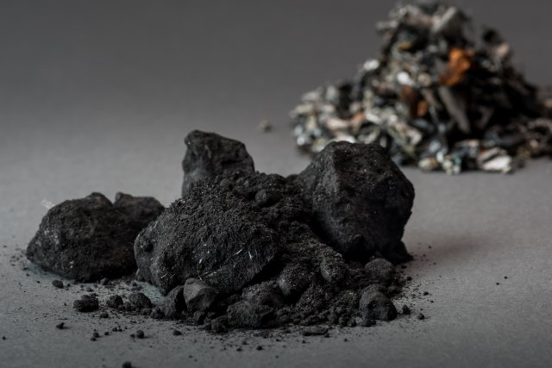
Black mass from shredded lithium-ion batteries. Source: Argonne National Laboratory. Click to enlarge.
Black mass contains the materials that can be further processed and made into new battery cathodes and anodes. Although the term “black mass” is commonly used, there are no industry standards for black mass. Depending on the batteries shredded and the type of shredding, there can be wide variation in the exact make-up and amount of liquid in this material. Black mass is frequently then sent to another facility that recovers the valuable metals (like cobalt, nickel, and sometimes lithium). Black mass may also be exported for this purpose. Other output materials, such as foils and steel canisters, may also be recycled through separate, dedicated pathways.
Although innovations are happening quickly in lithium-ion battery recycling, currently there are two main methods to recover the metals out of black mass:
- A heat-based smelting process (pyrometallurgy).
- A liquid-based leaching process (hydrometallurgy).
In some cases, the heat-based process can also be used to recover metals from batteries without an initial shredding step. Generally, smelting can recover cobalt and nickel, but it would take additional steps to recover other critical materials like lithium from the residue left behind. Recycling technologies that use leaching may be able to economically recover high amounts of cobalt, nickel, lithium, and manganese and several facilities are in development in the United States.
After smelting or leaching, the recovered metals must be processed further to be made into new batteries. At this point, the processing would look similar or identical to making battery components out of non-recycled metals.
In addition to the two main recycling techniques, some researchers and recyclers are experimenting at smaller scale with a technique called direct recycling in an effort to bring it to market. Direct recycling, sometimes called "cathode to cathode recycling," saves energy by preserving the highly engineered cathode structure that is the most valuable part of the lithium-ion battery and reducing the amount of manufacturing needed to recycle these materials into a new battery.

Lithium-Ion Battery Reuse
Reuse and repurposing are two similar, environmentally friendly alternatives to recycling or disposal of a lithium-ion battery that no longer meets its user’s needs or is otherwise being discarded. Battery performance degrades over time, but used batteries can still provide useful energy storage for other applications. For example, an electric vehicle battery that no longer holds enough energy to cover the range its owner desires could be reused as an electric vehicle battery for someone who requires less range from their vehicle, or it could be repurposed into a battery for storing energy from solar panels.
Reuse and repurposing options are still being developed, but could someday provide batteries a “second life” on a larger scale before they get recycled. This second life would benefit the environment by extending the useful life of the battery and decreasing resource demands for making new batteries.

Additional Resources
For more information on lithium-ion battery recycling, check out the following resources:
- EPA Resources:
  - Lithium-ion Battery Recycling FAQs.
  - Used Lithium-Ion Batteries.
  - Frequent Questions on Lithium-ion Batteries.
  - Universal Waste Webpage: Batteries section.
  - Workshop on Lithium-Ion Batteries in the Waste Stream.
  - Battery Collection Best Practices and Battery Labeling Guidelines.
  - EPA Memo: Lithium Battery Recycling Regulatory Status and Frequently Asked Questions (pdf).
- Department of Energy ReCell Center for Advanced Battery Recycling webpage.
- National Renewable Energy Lab report: A Circular Economy for Lithium-Ion Batteries Used in Mobile and Stationary Energy Storage (pdf).

