Yes, You Can Recycle Cooking Oil

https://earth911.com/home-garden/yes-you-can-recycle-cooking-oil/

By Amanda Wills
MAR 16, 2021
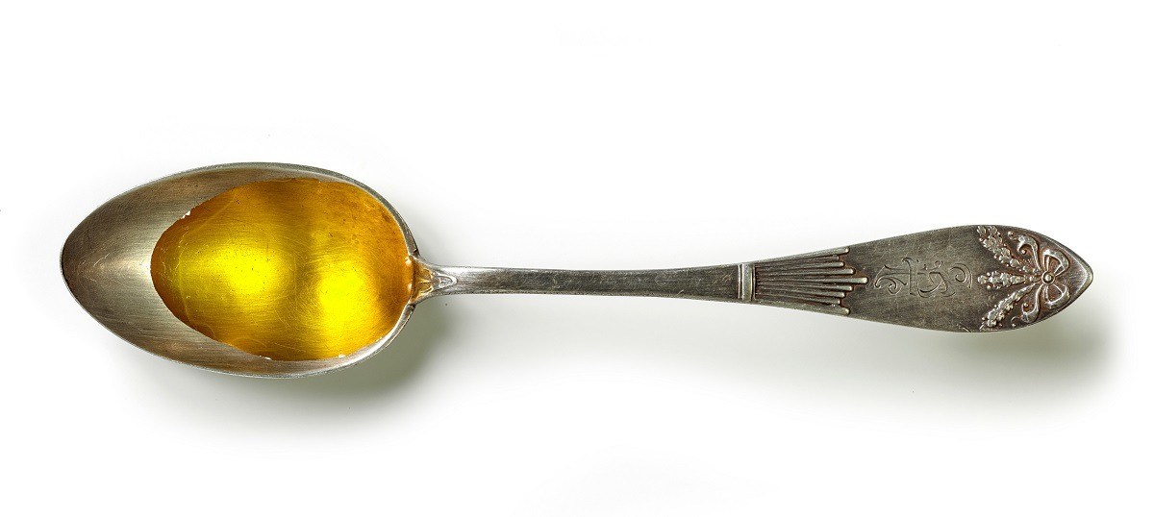
After you’ve fried the chicken or sautéed the veggies, don’t pour the leftover cooking oil down the drain. While it may seem harmless, pouring used oil down the drain can wreak havoc on your home’s plumbing and local sewage systems.

Collect Your Cooking Oil
If you’re not already collecting leftover cooking oil in a container beside the stove (just like Grandma!), chances are your drain has some substantial buildup. Even though it’s liquid, oil, like grease, clings to pipes in small particles that latch onto each other, collecting until you have a clogged drain — or worse. In fact, cooking oil and kitchen grease are a major cause of fatbergs that clog sewer pipes.
Plumbers will tell you to pour leftover cooking oil and grease into an old can, jar, or plastic jug, and when it’s cooled, just seal the container and toss it in the trash. But there’s an alternative to throwing it out.

Recycle Cooking Oil for Alternative Fuel
That’s right, your used cooking oil can be refined into an alternative fuel, or biofuel, that burns clean in most diesel engines. While many commercial facilities already contribute substantial supplies of oil for recycling, some programs invite households to recycle their excess cooking oil as well.
Use Earth911 Recycling Search to find a recycling location near you that accepts cooking oil.
*Please note that our Regional Household Hazardous Waste Center accepts used cooking oil but this does not show up on the Earth911 Recycling Search. Their information is listed below:
Household Hazardous Waste Center
1400 SW 22nd St. Willmar
(320) 231-3587
Hours: Monday thru Friday 8:00 AM to 4:00 PM

Also, some biofuel or biodiesel companies may provide additional drop-off locations around food-related holidays, such as Thanksgiving, so take advantage.
Be sure to check with the recycler for their requirements for oil storage and preparation and follow their guidelines. In general, don’t mix any water with the oil, try to filter out bits of food floating in the fat, and store the oil in a tightly sealed container.
Does filtering bits of food out of old oil sound gross? It’s not as bad as having to clean out your clogged drains later!

